**SendGrid Integration with Python Code**

|  |  |
| --- | --- |
| Team ID | PNT2022TMID23716 |
| Project Name | Smart Fashion Recommender Application |

**FLASK MAIL IS USING HERE BECAUSE SENDGRID IS NOT WORKING**

#importing libraries from flask

import Flask

from flask mail

import mail

Message app = Flask( name)

mail = Mail(app) # instantiate the mail class

# configuration of mail app.config['MAIL_SERVER']='smtp.gmail.com' app.config['MAIL_PORT'] = 465 app.config['MAIL_USERNAME'] ='yourId@gmail.com' app.config['MAIL_PASSWORD'] = '*****' app.config['MAIL_USE_TLS'] = False app.config['MAIL_USE_SSL'] = True mail = Mail(app)

#message object mapped to a particular URL ‘/’ @app.route("/") def index(): msg=Message(

'Hello', sender ='yourId@gmail.com', recipients = ['receiver’sid@gmail.com']

)

msg.body = 'Hello Flask message sent from Flask-Mail' mail.send(msg) return 'Sent'

if name == ' main':

app.run(debug = True)

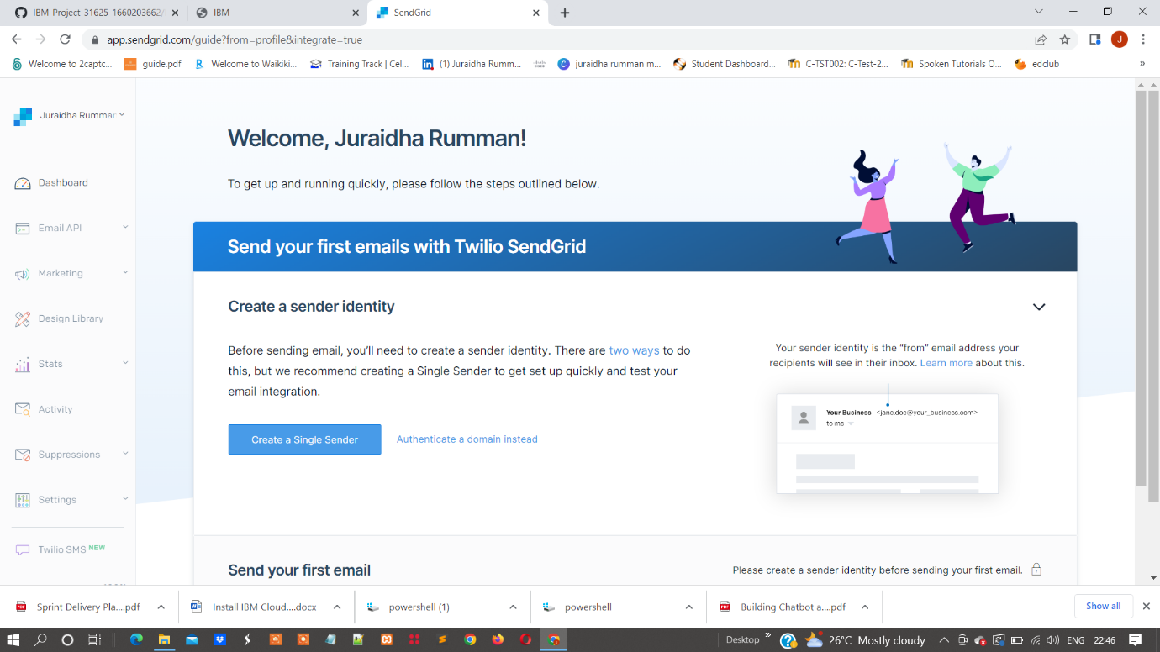Sendgrid:

IBM Cloud CLI:

